River Isle

River Isle
Rivier
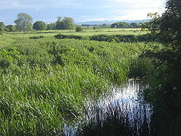
River eiland op Isle Brewers
Land | Engeland
Provincie | Somerset
Regio | Somerset Levels
Steden | Isle Brewers , Ilminster
Bron
- Locatie | Donyatt, Somerset , Engeland
- Coördinaten | 50°55′10″N 2°56′23″W50.91944°N 2.93972°W 50 ° 55'10 "N 2 ° 56'23" W 50,91944 ° N 2,93972 ° W
Mond | River Parrett
- Coördinaten | 51°00′32″N 2°49′55″W51.00889°N 2.83194°W 51 ° 00'32 "N 2 ° 49'55" W 51,00889 ° N 2,83194 ° W
Lengte | 8 mijl (13 km )
De rivier de Isle (ook bekend als de rivier de Ile) stroomt vanaf de bron in de buurt Ilminster , door middel van Somerset a en lozingen in de rivier de Parrett zuiden van Langport in de buurt Midelney .

